
STUDENT CASE STUDY EXECUTION REPORT
Department | FED
Subject | DSA -2
Academic year | I – III Semester(2025-26)
Faculty Name | V. GopiKrishna
Student Name | K. Sriram
Roll Number | 2520040072
Branch | ECE
Course Outcome | 5

Case Study Topic : EventSphere Session Scheduling using Activity Selection Algorithm
EventSphere is a smart event planning and management platform used to manage event schedules, venue bookings, registrations, and analytics.
During a technical fest, multiple sessions are planned on the same day.
To maximize the number of sessions without time conflicts, EventSphere uses the Activity Selection Algorithm.
For one event day, the sessions are:
Session | Start Time | End Time
Session 1 | 9AM | 10AM
Session 2 | 10AM | 12PM
Session 3 | 11AM | 1PM
Session 4 | 2PM | 4PM
Session 5 | 3PM | 5PM
The system must select maximum sessions without overlap.
Activity Selection is used.

Question
Using the EventSphere session scheduling scenario:
- Store session start and end times
- Apply Activity Selection
- Select maximum non-overlapping sessions
- Display selected sessions
- Calculate execution time
- Explain why Activity Selection is suitable

Analysis & Implementation

1.1 Session data
Inserted sessions:

Session 1 – 9AM to 10AM
Session 2 – 10AM to 12PM
Session 3 – 11AM to 1PM
Session 4 – 2PM to 4PM
Session 5 – 3PM to 5PM

Rule:
- Sort by finish time
- Select earliest finishing session
- Compare next sessions
- Add only if no overlap

1.2 Selected sessions
Selection order:

Session 1 (9AM – 10AM)
Session 2 (10AM – 12PM)
Session 4 (2PM – 4PM)

Rejected:

Session 3
Session 5

because timings overlap.
Maximum sessions selected = 3

1.3 Time complexity
Sorting:

O(n log n)

Selection:

O(n)

Overall:

O(n log n)

1.4 SLA calculation
Given:
- one operation = 200 ns
- budget = 5 ms
Approximate:

10 operations

Worst-case:

10 × 200 ns = 2000 ns

Convert:

2000 ns = 0.002 ms

Percentage:

(0.002 / 5) × 100
= 0.04%

System satisfies SLA.

1.5 Why Activity Selection is suitable
Advantages:
- simple greedy approach
- maximum session scheduling
- avoids conflicts
- efficient
- scalable
For EventSphere:
- more sessions in one day
- better schedule management
- avoids time clashes
- improves event planning

2. Final reasoning
For EventSphere:
- sessions stored successfully
- maximum sessions selected
- no overlapping
- fast execution
Activity Selection is suitable for EventSphere scheduling.

Code:
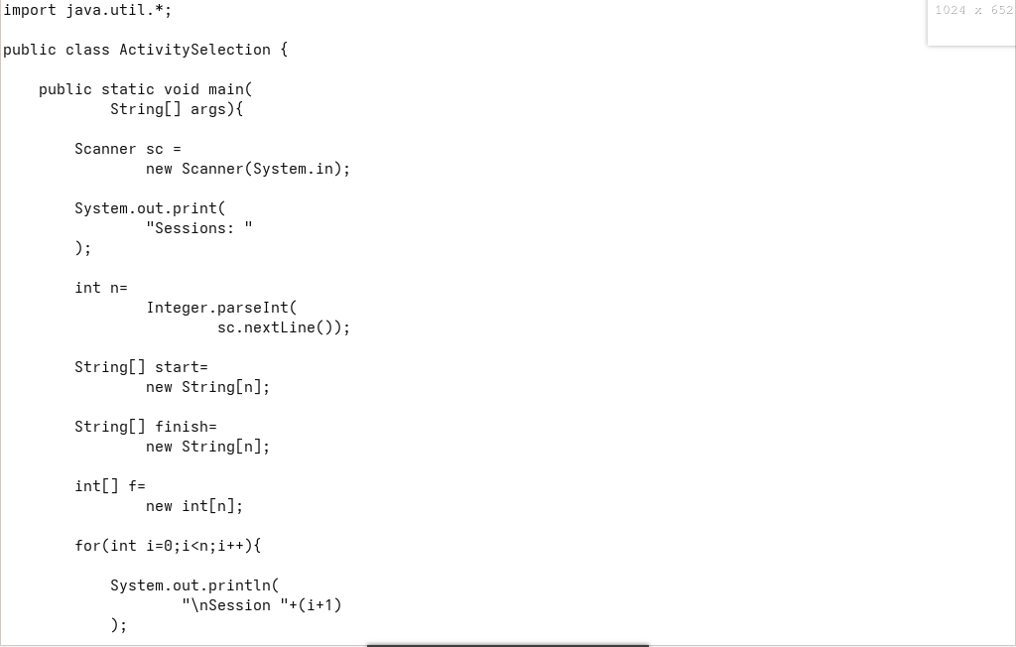

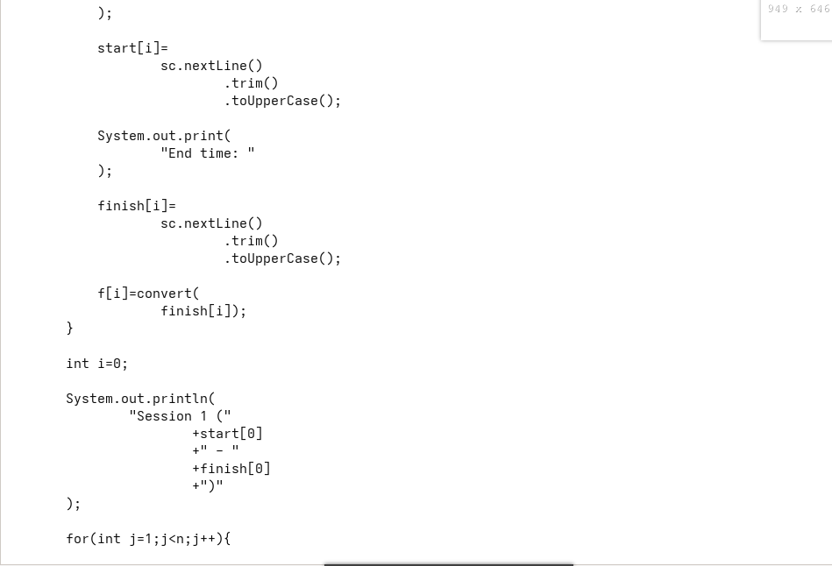

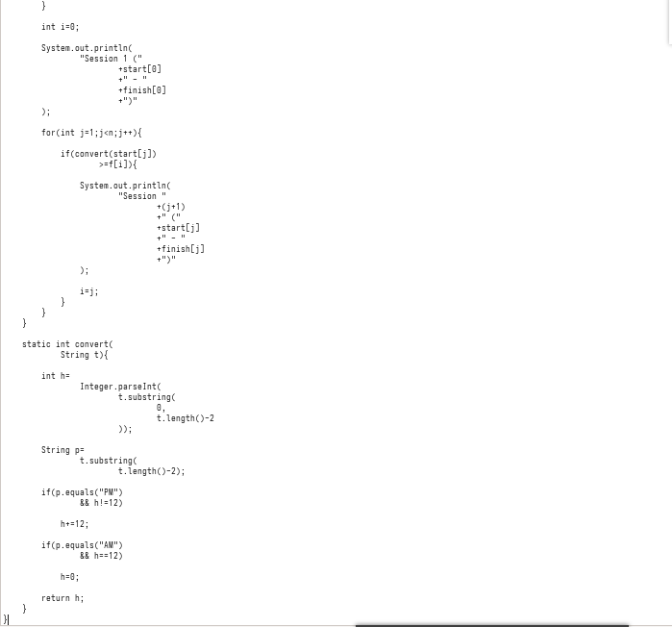

Output:

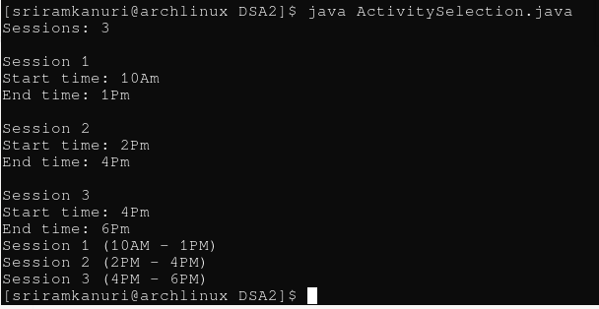

GitHub Link: https://github.com/kanurisriram/EventSphere

Student Signature | Faculty Signature
____________________ | ___________________

